RESOLUTION NO.__________

RE: CERTIFICATE OF APPROPRIATENESS UNDER THE
PROVISIONS OF THE ACT OF THE PENNSYLVANIA
LEGISLATURE 1961, JUNE 13, P.L. 282 (53
SECTION 8004) AND BETHLEHEM ORDINANCE NO.
3952 AS AMENDED.

WHEREAS, it is proposed to remove and replace windows and repair masonry at 416 E 4th St.

NOW, THEREFORE, BE IT RESOLVED by the Council of the City of Bethlehem that a Certificate of Appropriateness is hereby granted for the work.

Sponsored by: (s)

(s)

ADOPTED BY COUNCIL THIS DAY OF

(s)
President of Council

ATTEST:

(s)
City Clerk

HISTORIC CONSERVATION COMMISSION

CASE # 435 – It is proposed to remove and replace windows and repair masonry at 416 E 4th St.
OWNER/APPLICANT: Brandon Benner / William Dohe

The Commission upon motion by Mr. Cornish seconded by Mr. Loush adopted the proposal that City Council issue a Certificate of Appropriateness for the proposed work described herein:

- The proposal to remove and replace windows and repair masonry at 416 E 4th St. was presented by William Dohe.

- The historic wood windows have been replaced with vinyl double–hung windows behind storm windows. These existing windows will be replaced with Marvin aluminum clad wood windows to fit the exact size of the existing openings.

- The existing door on the second floor front will be maintained as a door opening. The existing door will be repaired and restored or replaced with a new wood door with half light above recessed panels similar in appearance to the existing.

- An historically appropriate steel guard railing will be installed in front of the new or repaired door. Shop drawings of the guard railing must be reviewed by the Historic Officer.

- An existing window on the side at the front corner that is currently infilled with aluminum siding may remain in the current condition.

- The existing masonry of the front façade will be structurally repaired. Steel tie-backs will be installed on the front façade on three levels: between 1st and 2nd floors, between 2nd and 3rd floors, and into the roof framing. There will be 2 per floor and they will be located at the third points of the façade.

- The tie-back will be either a star design with a circular backer (around 8” in diameter) or a round rosette design of similar size.

- The masonry around the paired double-hung window on the second floor will be repaired and a new steel lintel installed. The existing segmental arch must be maintained.

- The existing brickote on the front facade will be painted brick red.

- The proposed motion was unanimously approved.
CU: cu

By: 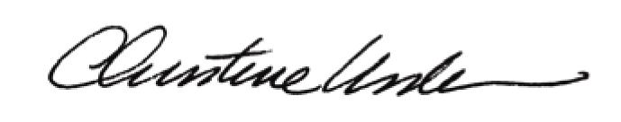

Date of Meeting: November 19, 2012 Title: Historic Officer

